MALTA
3rd Degree Curriculum

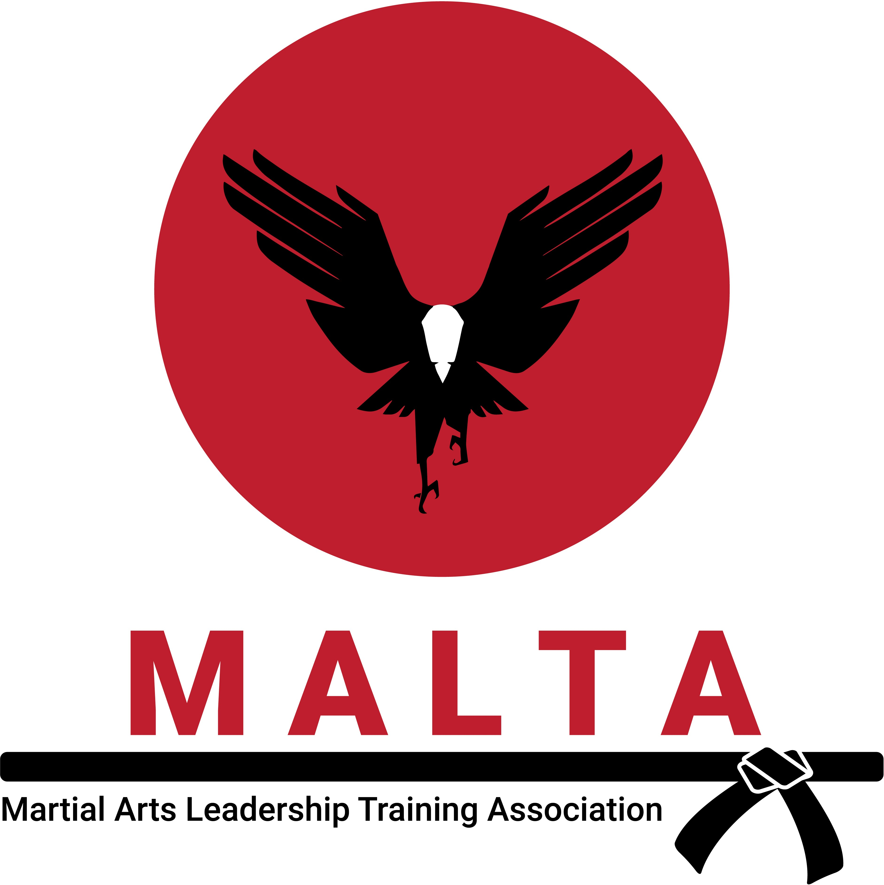

“Be Proactive”

Rotation 1

Basics:

- Fold Uniform
- 360 Roundhouse Kick

Grabs:

- First Wrist – cross grip
- First Wrist – Straight Grip

Self Defenses

- Salute Series
- Roundhouse Punch, Elbow Series
- Straight Punch – Cut monitor, cut neck

Sparring Combinations:

4, 5, 6, 7 Matching, Mirroring, Complementary

Kata:

Double Chase to music

“Begin with the End in Mind”

Rotation 2

Basics:

- History of Karate
- 360 Hook Kick

Grabs:

- Two Hand grab from rear – Kotegash (Left side)
- Arm up behind the back – ending in figure four (Left side)

Self Defenses (Left Side)

- Right palm heel block, backfist into knife hand block against second punch, ridgehand, over the leg take down, stomp
- (Against a front kick) Low block, backfist, reverse punch, shin kick, left cut elbow
- (Against roundhouse kick) Knee elbow block, left palm heel, right elbow, chop to neck, 3 knees.
- Roundhouse Peel Off
- Unbendable Arm

Sparring Combinations:

- Sticks – 4, 5, 6 & 7 mirroring
- Bo Sparring (Shinai)

Kata:

Honto

“Think Win Win”

Rotation 3

Basics:

1. Spin Hook

Grabs:

1. Shio Nage

Self Defenses:

Palm Heel block, strike to the throat, reverse figure four takedown Gun – Front, stomach, back, side

Sparring Combinations:

- Sticks - Inside raps 2, 4, 6
- Disarm 3 and 4
- Kickboxing Drills

Kata:

Empi

“Seek First to Understand”

Rotation 5

Basics:

- Tornado
- 360 Hook

Grabs (Self Defenses):

Roundhouse punch – Peel off Roundhouse punch – Unbendable arm

Self Defenses:

2nd Knife Template Side 1

Sparring Combinations:

- Sticks – Inside cuts
- Bo Sparring (Shinai)

Kata:

Honto

“Synergy & Sharpen the Saw”

Rotation 6

Basics:

- Hakama Pants
- Jump Spinning Reverse Crescent

Grabs:

- Grappling – Ankle lock from Fulcrum sweep
- Knee Bar from Fulcrum Sweep

Self Defenses:

2nd Knife Template side 2

Sparring Combinations:

- Sticks – Outside raps and cuts 2, 4, 6
- 3 Umbrella blocks

Kata:

Sword Kata/ Bokken Drills

