MASTER’S CLUB PROGRAM

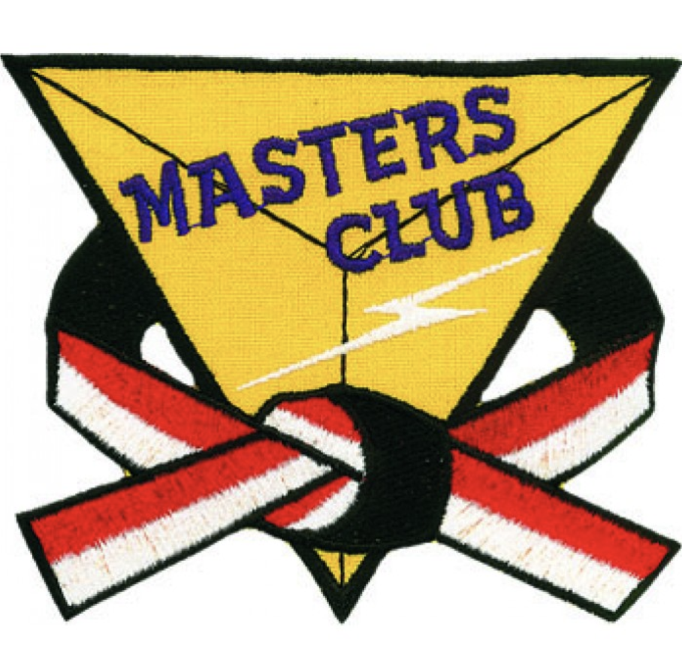

For Those Who Are Committed to their next level of Black Belt

Master’s Club Program

Black Belt through next level
Training Curriculum

4 year Timeframe
2 years average

Certified Instructor Training
Junior and Adult

Weapons Systems
Sword, Escrima Sticks,
Sparring Bo

Unlimited Class Attendance
May attend lower belt classes
M
A
S
T
E
R
S

C
L
U
B

MASTER’S CLUB PROGRAM

790
Initial Investment

TUITION SCHEDULE

295/24 months

MASTER’S CLUB PROGRAM

$295/24 months = $7,080

Single Installment ____________

SAVES $____________

MASTER’S CLUB PROGRAM

395
Initial Investment

TUITION SCHEDULE

169/24 months

MASTER’S CLUB PROGRAM

$169/24 months = $4,056

Single Installment ____________

SAVES $____________

