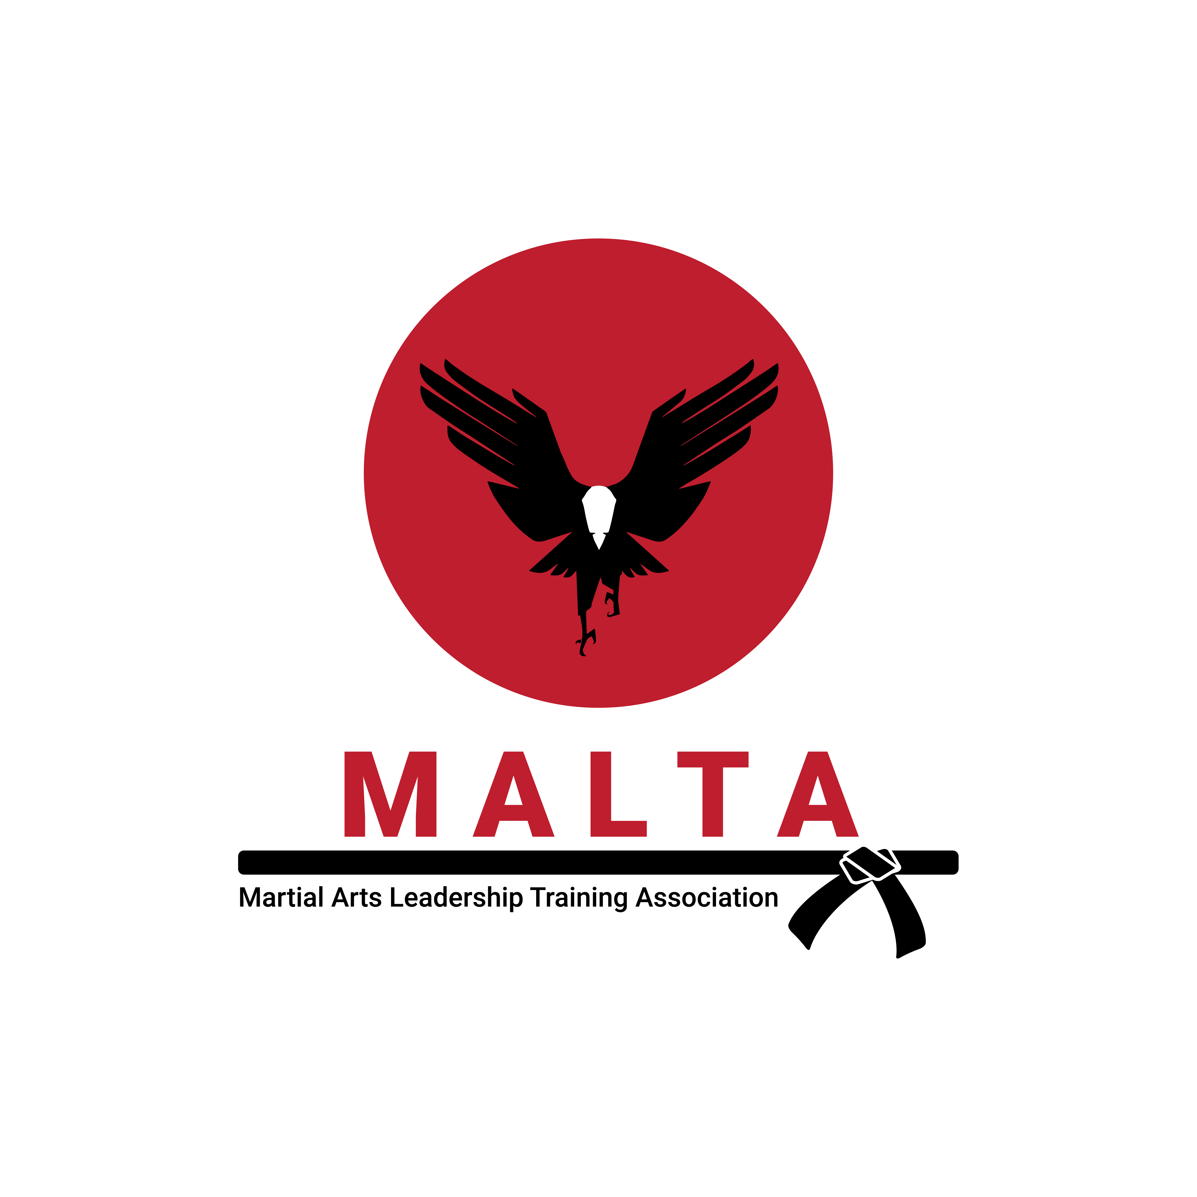
Nunchaku Certification

Nunchaku Kata Certification
Chase

Testing Points

- Two circles when you announce the form

- Step OUT and OVER

- Strike making a rotation above the arm

- Strike in horse stance with left hand stopping in front of the belly button

- Same – step OUT and OVER

- On the knee make sure standing knee is 90 degrees, back foot is on the ball

- Look over shoulder before/as you kick

- Open hand high block

- Black belts, chuck never touches body on the spin

- Thumb down when chuck goes around the head

- Thumb down when chuck goes around the head when stepping around

- Chucks against arm when performing the high block

- Step up at the end

