MALTA
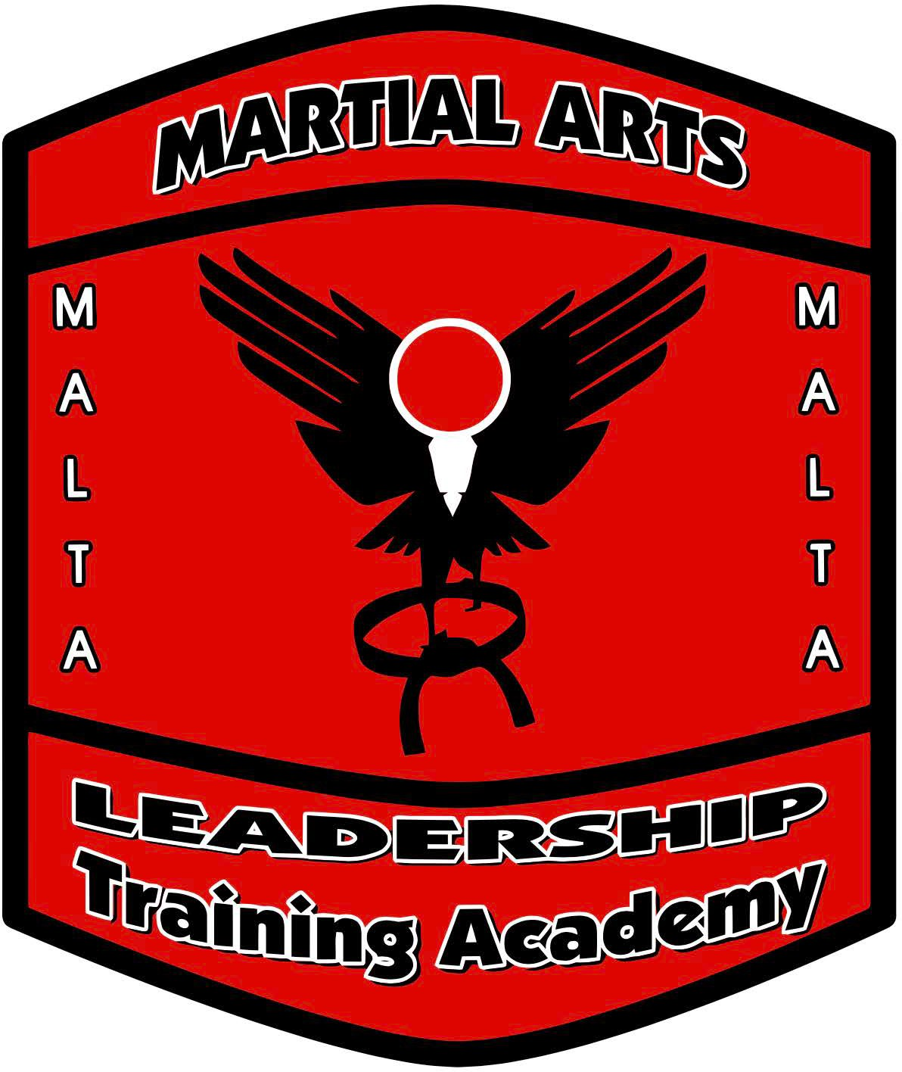
ROTATION 2 CERTIFICATION MANUAL

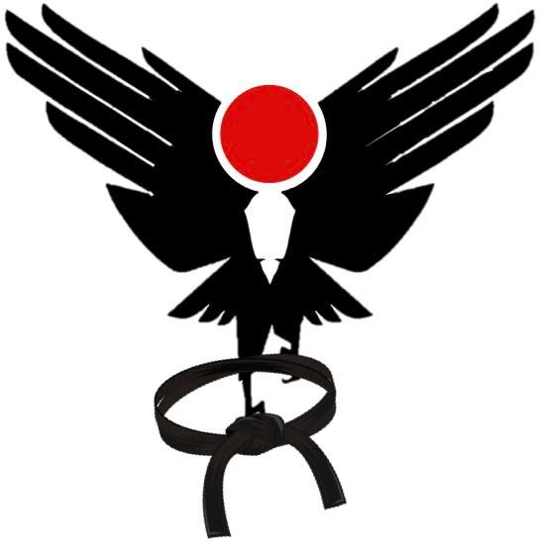
MALTA Staff Training

Basics - Stances
Beginner Testing points

# 1 #2 #3

Ready | Tight Fists | Feet Shoulder  Width Apart | Hands out in front,  45 degrees
Attention | Feet Together | Hands straight down by your  side | “Sir!” or  “Ma’am!”
Bow | Feet Together, legs straight | Eyes down | Bending at waist just past 45  degrees

NOTES

MALTA Staff Training

BASICS - STANCES
Beginner Testing points

# 1 #2 #3

Horse | Knees bent over  the big toe | Back Straight | Feet wide knees  “bowed”
Forward | Front knee bent so you can’t see your toe | Back leg straight | Feet shoulder width wide, double shoulder width long
Fighting | Ball of front foot and heel of back  foot on same line | Body at 45 degree | Knees slightly bent
At Ease | Feet shoulder  width apart | Hands clasped  behind back | Body at attention,  eyes straight ahead

NOTES

BASICS – FALLS/Belt
Beginner Testing points

# 1 #2 #3

Side Fall | Barrel roll all the way on your side | Smacking the ground with the bottom hand | Body in fetal position, smacking hand protecting  the face
Back Fall | Head never touches the ground | Hitting floor with both hands  when belt touches ground | Not “catching” yourself
Belt | Knot points to student’s right | Stripes on heart side | If double wrap, knot wraps around  both

NOTES

BASICS - Blocks

Beginner Testing points

# 1 #2 #3

Low Block | Hand just past knee, 4-6 inches  above | Tight fists | Slight bend in the elbow
High Block | Above the head  like a roof | Hand in fist | Arm NOT  touching the head
Inside Block | Elbow at 90  degrees | Hand in fist | Arm comes to  center of body
Outside Block | Hand just past  the shoulder | Hand in fist | Elbow 90 degrees
Palm Heel  Block | Hand in  Chamber | Thumb tight  against hand | Hand goes past  face
Knee-Elbow | Knee and elbow  touches | Body turns  totally to the side | Look over  shoulder

NOTES

MALTA Staff Training

BASICS - Kicks

Beginner Testing points

# 1 #2 #3

Front Kick | Knee bent before  foot comes out | Toes up striking  with ball of foot | Recall foot so  knee bends again
Side Kick | Knee chambers with heel  pointing to target | Heel pushes out straight line to  target | Toes pointing sideways
Hook Kick | Starts as side kick | Bend knee so heel comes  through target | Hands by the face
Flip Kick | Knee points to  target | Striking with  instep | Recoil foot before  landing
Roundhouse  Kick | Pivot on front  foot | Striking with  instep | Don’t over rotate

NOTES

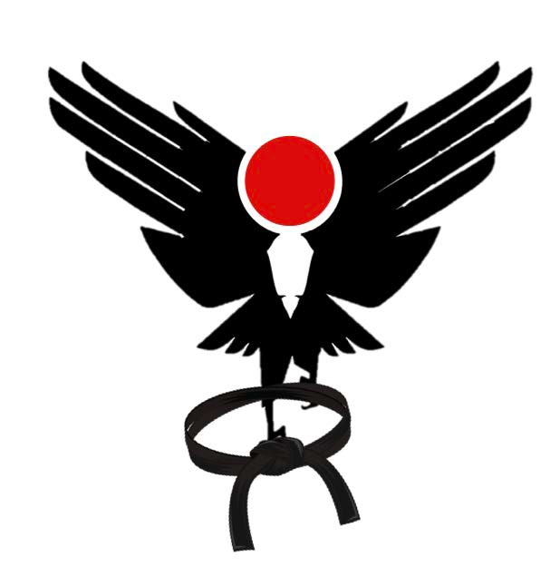

BASICS – Hand Techniques (Punches)

Beginner Testing points

# 1 #2 #3

Basic Punch | Chamber on belt  on hip | Hand turns over  last three inches | Striking with first  two knuckles
Backfist | Elbow out first | Striking with back of hand | Concentrate on  bringing the hand back fast!
Reverse Punch | Elbow grazes the ribs on the way  out | Hand turns over the last three  inches | Pivot foot and hips

NOTES

BASICS – Hand Techniques (Open Hand)

Testing points

Knives

# 1 #2 #3

Straight Chop | Striking with  Shuto edge | Start with hand  to ear | Pivot
Overhand Chop | Start with hand  to ear | Hand in  Chamber | Pivot
Cross Chop | Start with palm  to opposing ear | Pivot away | Stop on jawline
Rear Hand Ridgehand | Starts as a Reverse Punch | Come through target with bending of the  elbow | Drop elbow immediately
Front Hand  Ridgehand | Starts as a jab | Front Heel pivots | Eyes on target

NOTES

GRABS
Beginner Testing points Rotation 2

# 1 #2 #3

Two Hand  Choke | Raise hand  straight up | Drop weight into  horse stance | Palm monitors  their arm
Double Wrap | Step between the legs | Arm goes all the way around | Punch with palm up
Arm Twist Behind the  Back | Grab them first | Make arm go above the  shoulder | Pull them in for the side kick

NOTES

SPARRING COMBINATIONS
Beginner Testing points Rotation 3

# 1 #2 #3

Backfist, Reverse Punch, Rearhand  Ridgehand | Specific different targets | Pivot on the Ridgehand | Hand by the face
Backfist, Reverse Punch, Fronthand  Ridgehand | Specific different targets | Pivot Heel | Hand by the face
Backfist, Reverse Punch,  Clearhead Punch | Clear to the inside | Momentum going forward | Don’t let go
Backfist, Sidekick | Shoot the backfist high | As punch comes back, side kick  goes out | Recoil kick

NOTES

Kata – Universal
Beginner Testing points Rotation 3

# 1 #2 #3

Universal | Proper foot Placement | Horse Stance with chamber | Solid Stances and hand position last  half

NOTES

Intermediate Basics
Intermediate Testing points

# 1 #2 #3

Back Stance | Horse stance with front foot  turned forward | Knife hand block with hands | Slight lean on back leg 60/40
Knife Hand Block | Tips to lips | Hand across stomach, fingertips to edge  of ribs | Back Stance

NOTES

Intermediate Basics - Kicks
Intermediate Testing points

# 1 #2 #3

Spinning Side  Kick | Spin Spot Kick | Turn only half  way | Recoil leg into  chamber
Spinning Hook  Kick | Spin 360 degrees | Pivot on standing  foot | Foot ends where it  started
Jumping Side  Kick | Rear leg kick | Knee comes into  chest | Recoil leg into  chamber
Jumping Front Kick | Step, knee up, kick | Momentum comes from  lifting knee | Land in fighting Stance

NOTES

Intermediate Basics - Kicks
Intermediate Testing points

# 1 #2 #3

Crescent Kick | Knee bends | Strike with the  “ankle” | Big Arc
Reverse  Crescent Kick | Knee bends | Strike with  “ankle” | Big Arc
Ax Kick | Half a Reverse  Crescent | Land forward | Striking with heel
Skipping Side Kick | Knee rises while standing foot  skips | Push the heel | Landing in fighting stance

NOTES

Intermediate Grabs
Intermediate Testing points Rotation 2

# 1 #2 #3

Sleeper Choke | Hit two points, shoulder and  elbow | Your elbow needs to be under  their chin | Squeeze with the “vise”
Sleeper Choke Escape | Grab their elbow | Drop straight  down, near leg up | Your finger goes to your center
Side Headlock | Turn face into their side | Grab elbows and step | Punch a straight  punch while hanging on

NOTES

Intermediate Sparring Combinations

Intermediate Testing points Rotation 3

# 1 #2 #3

Full Contact  Drills | Hand by the face | Pivoting hips | Elbow and hips  connected

NOTES

Advanced Self Defenses
Advanced Testing points Rotation 3

# 1 #2 #3

Palm Heel,  Straight Chop, Side Kick | Step to right | Pivot on Chop | Make it a side kick
Palm Heel,  Backfist Ridgehand | Step to right | Elbow points to face | Pivot on the Ridgehand
Inside Block, Cross Chop, Punch, Front  Kick | Step to the right | Glancing block with pivot | Front kick when balanced
Outside Block,  Groin Grab, Chop, Side Kick | Step out 45 degrees | Pivot out on chop | Target the  midsection for side kick

NOTES

Pre-Black Knives
Pre-Black Testing points Rotation 3

Knives

# 1 #2 #3

Slash – Karate | Block and ridgehand with  step | Solid Figure Four | Take down in a circle
Slash – Aikido | Handshake off centered | Go under lower than their  shoulders | Sit on Heel

NOTES

