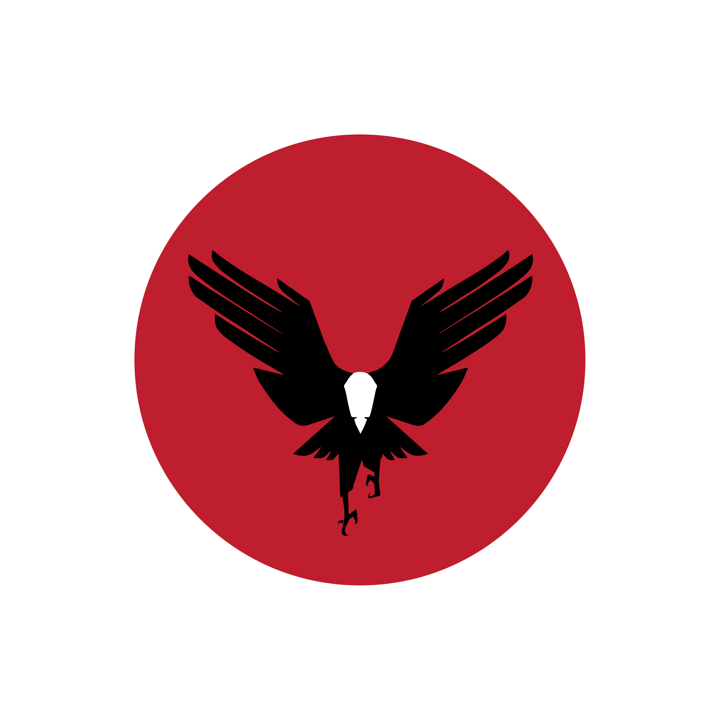
Black Belt Program
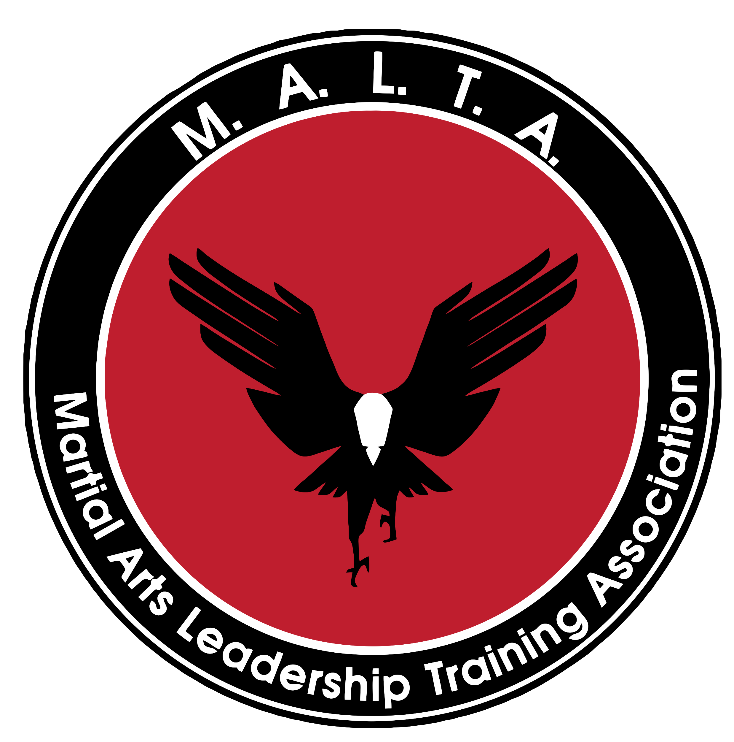

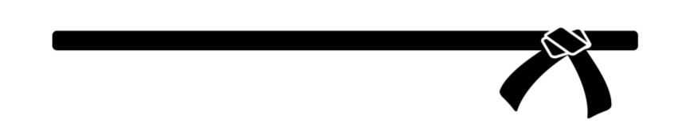

We are a Black Belt School
The goal is Black Belt

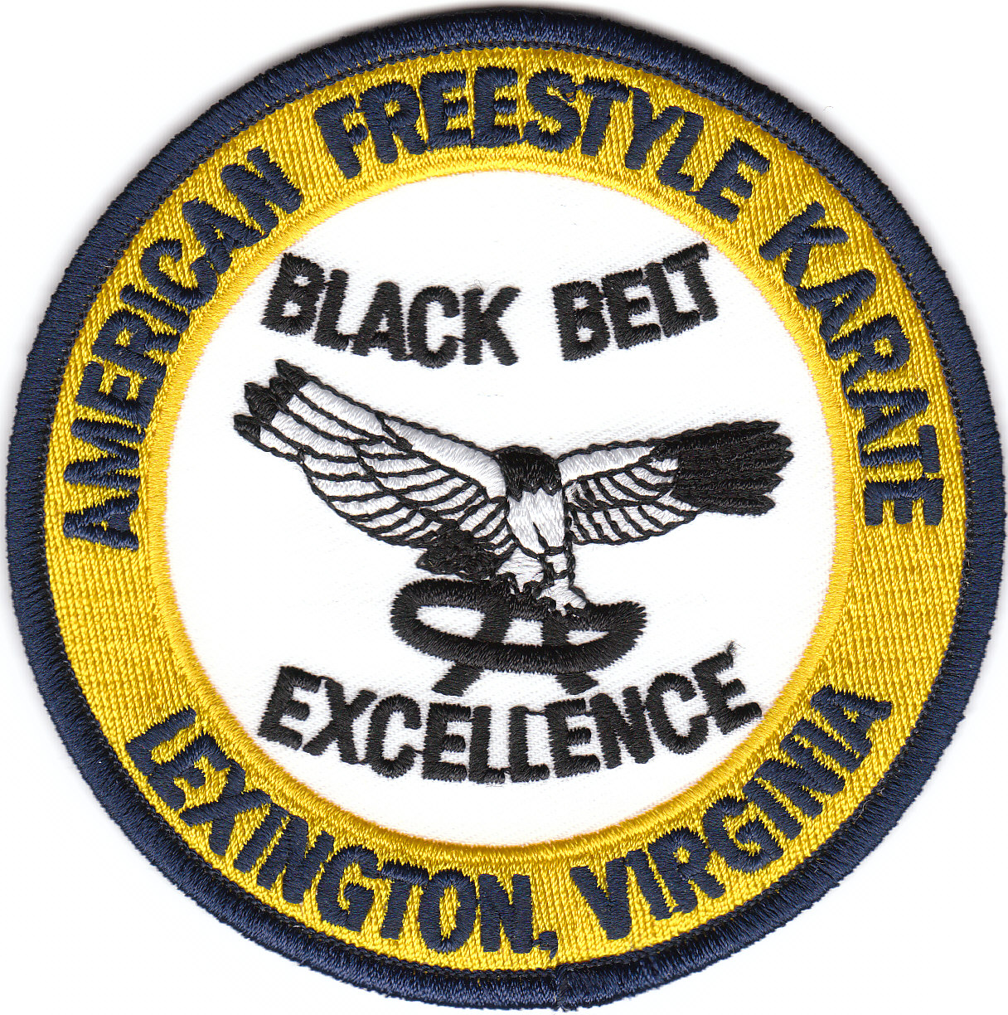
B
Black Belt Program

White through Black Belt
Training Curriculum

Five Year BBP Timeframe
Three years average

6 Tasks Life Skills Program

Words of the Belt Life Skills Program

Unlimited Class Attendance

Access to all School Seminars
Purchase of equipment may be necessary

L

A

C

K

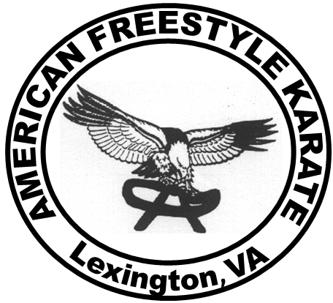

B

E

L

T

B
Black Belt Program

Certified Instructor Training
Junior and Adult

Class Sparring
Safe Martial Art Application

Board Breaking
Confidence and Power Development
Basic and Advanced

Weapons Systems
Develops Hand-Eye Coordination
and Physical Strength

Self Defense Systems
Basic and Advanced

L

A

C

K

B

E

L

T

BLACK BELT PROGRAM

295
Initial Investment

TUITION SCHEDULE

149/36 months

BLACK BELT PROGRAM

149/36 months = 5,364

Single Installment _____________

SAVES______________

BLACK BELT PROGRAM

590
Initial Investment

TUITION SCHEDULE

275/36 mont

BLACK BELT PROGRAM

275/36 months = 9,900

Single Installment _____________

SAVES______________

