Martial Arts Leadership
Training association

Curriculum

Class Notes

Rotation 1

Words of the Belt

Self Control  Control Mouth  Control Body  Pay attention in class  Eyes, Mind, Body  Don’t Interrupt  Work before play  Attitude of gratitude  Listen to the teacher  Follow the rules  Say please and Thank you  Ask before you do  things  Think before you speak  Do what you are told  WHEN you are told | Focus  Concentrate on one  thing at a time.  Pay attention  Dedication  No distractions  Concentrate on tests  Write down your goals  Prepare to focus | Confidence  Believe in your abilities  Is it ok to fail?  Experience success  Get back up  Hold yourself up  Know the details  Look people in the eye  Promote others  Know your strengths  and weakness  Practice

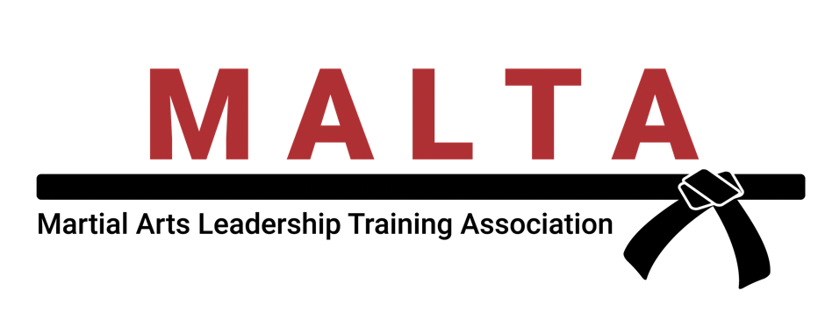

Rotation 1 - Intermediate
Basics Week
Knowledge

Intermediates
Spinning Hook
Spinning Side
Crescent
Reverse Crescent
Spinning Reverse Crescent
Front Roll
Back Roll

Extra:
Sparring (padded sticks, then head and hands)
Chase

Fun Exercises:
- Forward stance into a front kick, stick the leg out and then recoil it but still keep it in the air and see if they can hold it as long as the instructor can.
After make sure to land off to the side.
- On the two lines used for forward stances on the mat and hold a x-ray target in front of them so they have to hit it with their front kick and then land (after recoiling) back on the appropriate line.
- Spinning side kick on bags, dominoes
- Spinning hook in the air, on the hand targets
- Have students partner up and squat. Have them high five with both hands and try to knock the other person over or have them fall forward without falling themselves. If they do fall they have to do a back roll.
- Crescent kicks over a chair
- Face each other and use your partner’s face as a target (at a distance!) for hook/crescent
- Leg holds – hold front, flip and side kick in the air for 15 seconds each

Rotation 1 - Advanced
Basics Week
Confidence
Advanced
Defensive Side
Jump Spinning Defensive Side

Extra:
Sparring

Fun Exercises:
- Partner holds Blast Master and charges their partner slowly at first and then speeding up as they do the kicks on the bag.
- Spinning Side Kick on Bag
- Spinning Side kicks—dominoes
- Side Kick on bags aiming at a piece of tape so their aim is good enough for breaking boards later the next week.

ROTATION 1 – Pre-Black
Basics Week

Adult Pre-Black
Jump Spinning Reverse Crescent Kick
Tornado Kick

Extra:
Sparring Rounds

Fun Exercises:
- Spinning Hook Kick on Targets
- Spinning Reverse Crescents on Targets
- JSRC/Tornado on targets

Rotation 1 - Beginner
Grabs Week
Self-Control

Beginners
Side Kick
Hook Kick
Wrist Escape
Push
Single Wrap

Black Belt Club:
Grabs on Partners
(Arm up behind the back)

Fun Exercises:
- Side kicks on bags
- Have students get close to bag and do 1 side kick on your command, having them focus on your voice, and see who on the bag can kick it fastest. Try to mix up the timing on when you yell the command to mess them up.
- Hook kick on x-ray targets

Rotation 1 - Intermediate
Grabs Week
Knowledge

Intermediates
Twist Offs:
Front
Pinky Up
Break the Elbow

Extra:
Chase

Fun Exercises:
- Crescent kicks over a chair
- Face each other and aim at your partner’s face
- Spinning Hook in air, on hand targets
- Spinning side kicks—dominoes
- Have students partner up and squat. Have them high five with both hands and try to knock the other person over or have them fall forward without falling themselves. If they do fall they have to do a back roll.

Rotation 1 - Advanced
Grabs Week
Confidence

Advanced
Board Breaks
Side Kick

Extra:
Chase
Basic Kata I
Star Form

Fun Exercises:
- Partner holds Blast Master and charges their partner slowly at first and then speeding up as they do the kicks on the bag.
- Spinning side kick on Bag
- Spinning side kicks—dominoes
- Side Kick on bags aiming at a piece of tape so their aim is good enough for breaking boards.
- Review Basic and Intermediate Grabs

Rotation 1 – Pre-Black
Grabs Week

Adult Pre-Black
Knives:
Straight— Karate and Aikido
Board Breaks:
Side Kick
Front Kick

Extra:
Grabs from Intermediate and Beginner cycles 3 and 1

Fun Exercises:
- Spinning Hook Kick on Targets
- Spinning Reverse Crescent Kicks on Targets
- JSRC/Tornado on targets

Rotation 1 - Beginners
Sparring Combination Week

Beginners
Backfist
Reverse Punch
Shuffle
Flip Kick
Backfist, Reverse Punch
Clear-Head, Punch
Flip Kick, Backfist, Reverse Punch
Flip Kick, Clear-Head, Punch

Black Belt Club Only:
Sparring

Fun Exercises:
- Partners try to tag each other’s shoulder’s without being tagged themselves
- Variation: Stick a quarter of a White belt in the students belts and see if they can take their partner’s piece away without losing their own.
- To work on timing and distance a S.T.O.R.M. person is surrounded by students and attack them with a Blast Master. Students have to front kick them away.

Rotation 1 - Intermediate
Sparring Combinations Week

Intermediates
Side Kick, Flip Kick
Hook Kick, Flip Kick
Side Kick, Flip Kick, Backfist, Reverse Punch
Hook Kick, Flip Kick, Backfist, Reverse Punch

Extra:
Sparring

Fun Exercises:
- Lounge on the beach while doing proper double action kicks in the air
- Slow Double Action kicks on the bags to work on aim and balance
- Face each other and aim at your partner’s face
- Spinning Hook in air, on hand targets
- Spinning Side kicks—dominoes
- Go up and down the floor practicing Knife hands with the back stance
- Have students partner up and squat. Have them high five with both hands and try to knock the other person over or have them fall forward without falling themselves. If they do fall they have to do a back roll.

Rotation 1 - Advanced
Sparring Combinations Week

Advanced
Palm Heel Block, Strike to Throat
Palm Heel Block, Strike to Throat, Wrap, Chop
Palm Heel Block, Punch to Body
Palm Heel Block, Punch to Body, Elbow to Face, Scoop Kick

Extra:
Sparring

Fun Exercises:
- Partner holds Blast Master and charges their partner slowly at first and then speeding up as they do the kicks on the bag.
- Spinning Side Kick on Bag
- Spinning Side kicks—dominoes
- Side Kick on bags aiming at a piece of tape so their aim is good enough for breaking boards.

Rotation 1 – Pre-Black
Sparring Combinations Week

Adult Pre-Black
Palm Heel Block, Punch to Body, Strike to Throat
Palm Heel Block, Punch to Body, Strike to Throat, Take Down,
Punch, Clench Fist
Inside Knifehand, Thumb in the Eye, Palm Heel, Punch to Body,
Scoot Up, Knee to Groin
Inside Knifehand, Clench Fist to Throat, Hammer Fist to Kidney,
Chop to Groin, Take Down, Crescent, Front, Ax

Extra:
Self Defenses from Advanced Cycles 3 and 1

Fun Exercises:
- JSRC/Tornado on targets
Rotation 1 - Beginner
Kata Week

Beginners
Forward Stance
Basic Punch
Roundhouse Kick
1st Half of Basic Kata I

Black Belt Club Only:
Kata to the Numbers
Chase

Fun Exercises:
- Have the students put each foot on 2 lines on the floor and have them practice their C-Step with the lines as a guide to where their feet should land.
- Jump over blocker, land in horse stance, punch punch. (Advanced: spin in air to face person behind them when landing in a horse stance.)
- Face partner and see who can punch fastest while in a horse stance on command.
- Practice blocks on one side with other hand tucked in belt

Rotation1 - Intermediate
Kata Week

Intermediates
Forward Stance
C-Step
2nd Half of Basic Kata I

Extra:
Chase
Review of 1st Half of Basic Kata I

Fun Exercises:
- Lounge on the beach while doing proper double action kicks in the air
- Slow Double Action kicks on the bags to work on aim and balance
- Face each other and aim at your partner’s face
- Spinning Hook in air, on hand targets
- Spinning Side kicks—dominoes
- Have students partner up and squat. Have them high five with both hands and try to knock the other person over or have them fall forward without falling themselves. If they do fall they have to do a back roll.
- Students partner up and watch each other do the kata and give helpful tips on how the other student can make it better.

Rotation 1 - Advanced
Kata Week

Advanced
1st 3rd of Moonform

Extra:
Chase
Basic Kata I
Starform

Fun Exercises:
- Go up and down the floor practicing Knife hands with the back stance
- Students partner up and watch each other do the kata and give helpful tips on how the other student can make it better.

Rotation 1 – Pre-Black
Kata Week

Adult Pre-Black
All of Moonform
Kama Kata
Chase

Extra:
Basic Kata I
Starform

Fun Exercises:
- JSRC/Tornado on targets

