

Name
STORM: Special Team of Role Models. Set the example for our karate family.
25 total checks earns a star
5 Stars earns a STORM patch.

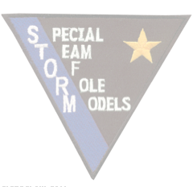
STORM Awards Program

 |  | 1 | 2 | 3 | 4 | 5 | 6 | 7 | 8 | 9 | 10 | 11 | 12 | 13 | 14 | 15 | 16 | 17 | 18 | 19 | 20 | 21 | 22 | 23 | 24 | 25 | 26 | 27 | 28 | 29 | 30
Ambiance | Spot check glass w/ paper towel
 | (kids) sweep main entry
 | (adults) swiffer main entry
 | Clean soap from bathroom sink
 | Tell instructor TP/Towels are out
Experience | Greet people on sidewalk
 | Open door / greet outside
 | Greet people inside
 | Help with iPad sign in
 | Help someone tie their belt
 | Mat Monitor
Invest | Meet someone new
 | Teach someone to tie their belt
 | Help with line up
 | Be a line up buddy
 | Be a pad holder
Share | Bring a friend to class
 | Post a class pic to FB
 | Post a karate pic on your FB
 | Hand out fliers after class

