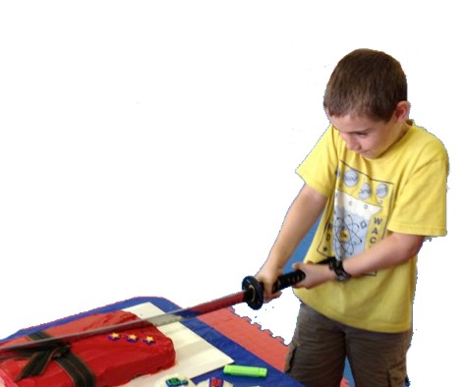


















































Your school address & ph here
AmericanFreestyleKarate
www.AFKLexinton.com
Add Ons.....

Pizza - $10 per large (fresh, hot, delivered, tip and tax) Helium Balloons - 15 latex, $20 (you keep after party) Drinks - $5 per 10 pouches
Extra Game Time - $40 for 1/2 hour

Extra Kids - $5 per kid per party

Extra Invitations - $5 per set of 8
Karate Party
$149

- The 1 1/2 hour party begins with the birthday kid and friends playing games in the karate studio as everyone arrives.
- Then we start the 30 minute KARATE
CLASS with lots of games and activities.
- The action continues with the cake cutting
ceremony with a REAL SAMURAI SWORD.
- A drink, plate, napkin, and utensil will be
provided for cake.
- Gift certificate for each kid for lessons.
- Colorful Invitations will be provided.
- Up to 15 kids

Avail. Sat/Sun afternoons
Samurai Party
$199

- The 1 1/2 hour party begins with the birthday kid and friends playing games in the karate studio as everyone arrives.
- Then we start the 30 minute KARATE
CLASS with lots of games and activities.
- The action continues with the cake cutting ceremony with a REAL SAMURAI SWORD that the birthday kid KEEPS ($60 value).
- A drink, plate, napkin, and utensil will be
provided for cake.
- Gift certificate for each kid for lessons.
- Colorful Invitations will be provided.
- Up to 15 kids

Avail. Sat/Sun afternoons

- The 2 hour party begins with the birthday kid and friends playing games in the karate studio as everyone arrives.
- Then we start the 30 minute KARATE
CLASS with lots of games and activities, Including BOARD BREAKING demonstrations and lessons!!!
- The action continues with the cake cutting ceremony with a REAL SAMURAI SWORD that the birthday kid KEEPS.
- Pizza for all kids
- Drinks plates, napkins, and utensils will
be provided for pizza and cake.
- Gift certificate for each kid for lessons.
- Colorful Invitations will be provided.
- Up to 20 kids, $5 per extra participant
$249
Avail. Sat/Sun afternoons
