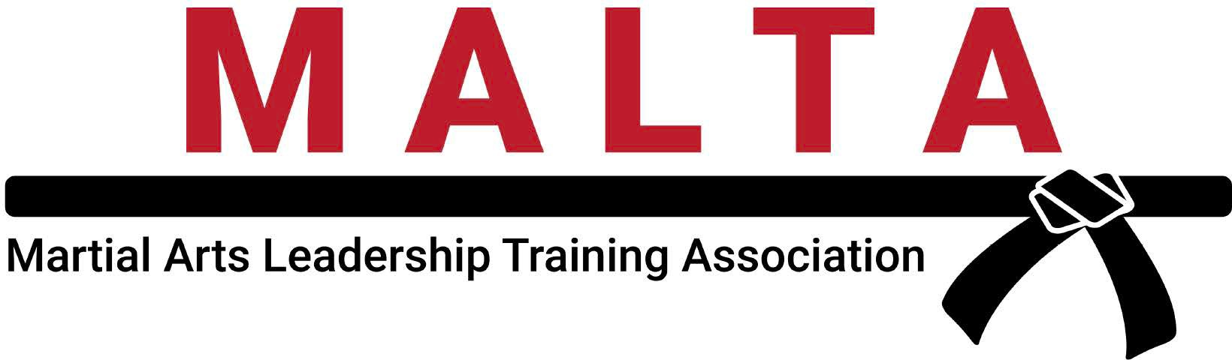

Student’s Name Belt Promotion:

INTENT TO PROMOTE

Dear Parents and Teacher,

This student is in the final preparation to meet our standards of curriculum proficiency to be promoted to the next belt level in American Freestyle Karate at our Martial Arts Leadership Training Academy.
However, we also consider the student’s behavior outside the Academy. To assist us in our decision if this student should be promoted, could you please take a few minutes and answer this questionnaire. These are the character traits we are developing in our students. Thank you for your cooperation.

Please circle the number that best describes this student’s effort:

Chief Instructor

5-Excellent 4-Above Average 3– Acceptable 2– Needs Improvement 1– Immediate Attention

Parents, Please rate your child on these areas of behavior:

SELF-DISCIPLINE: | 5 4 3 2 1 | SOCIAL SKILLS: | 5 4 3 2 1
ATTITUDE: | 5 4 3 2 1 | BEHAVIOR: | 5 4 3 2 1
RESPECT: | 5 4 3 2 1 | CONCENTRATION: | 5 4 3 2 1
CONFIDENCE: | 5 4 3 2 1 | ORGANIZATION: | 5 4 3 2 1
INTERACTION WITH SIBLINGS: (IF APPLICABLE) 5 4 3 2 1

Teacher, please rate this child on these areas of behavior:

SELF-DISCIPLINE: | 5 4 3 2 1 | SOCIAL SKILLS: | 5 4 3 2 1
ATTITUDE: | 5 4 3 2 1 | BEHAVIOR: | 5 4 3 2 1
RESPECT: | 5 4 3 2 1 | CONCENTRATION: | 5 4 3 2 1
CONFIDENCE: | 5 4 3 2 1 | ORGANIZATION: | 5 4 3 2 1
HOMEWORK COMPLETED ON TIME: 5 4 3 2 1
Comments:

FREE ANTI-BULLYING CONFIDENCE WORKSHOP
This seminar could change your classroom!
Let one of our professional Black Belt instructors from our Martial Arts Leadership Training Academy teach your classroom about Anti-Bullying, Confidence and Child Safety Awareness. For a free 30-40 minute Safety Awareness workshop in your classroom, please include your name, phone number and the best time to call to schedule a time.

Teachers Name: Phone Best time to call

